
Apache Installation
VERSION: 1.0

Key Contacts

- Venkatesh Balaji,
Enterprise Architecture
Solverminds Solutions and Technologies Pvt Ltd
vbalaji@solverminds.com

- Mahendran.T,
Associate Project Leader
Solverminds Solutions and Technologies Pvt. Ltd

Table of Content

1. Introduction 3
2. Prerequisite 3
3. Procedure 4
3.1 Step 1 4
3.2 Step 2 4
3.3 Step 3 5
3.4 Step 4 5
3.5 Step 5 6
3.6 Step 6 6
3.7 Step 7 7
3.8 Step 8 9
3.9 Step 9 10
3.10 Step 10 10
3.11 STEP 11 11
3.12 Step 12 11
3.13 Step 13 11
3.14 Step 14 11
3.15 Step 15 12
3.16 Step 16 12
3.17 Step 17 13
4. Testing 13

Introduction

This Purpose of this Document is to provide the Installation steps and configuration settings for Apache 2.2.25 Open SSL.

Prerequisite

Purpose | Requirement
Kindly download the Apache 2.2.25 from the following link | http://www.softpedia.com/get/Internet/Servers/WEB-Servers/Apache-HTTP-Server-for-Windows.shtml
Listed files to be required before commencing installation | 1) mod-jk.conf  2)v_host.conf  3)mod_jk.so  4)workers.properties file
Wildcard SSL Security Certificate files | - SSLCertificateFile should be your DigiCert certificate file (eg. your_domain_name.crt).  - SSLCertificateKeyFile should be the key file generated when you created the CSR.  - SSLCertificateChainFile should be the DigiCert intermediate certificate file (DigiCertCA.crt)
Application Login | Pulse Planet Application Login details from DB

Procedure

Step 1

Double click the httpd-2.2.25-win32-x86-openssl-0.9.8y.msi & follow the instructions on the screen

Step 2

Kindly enter Network Domain (for example : SOLVERMINDS.COM)
Server Name (for example : TESTSERVER.SOLVERMINDS.COM)
Administrator's Email Address (for example : admin@SOLVERMINDS.COM)
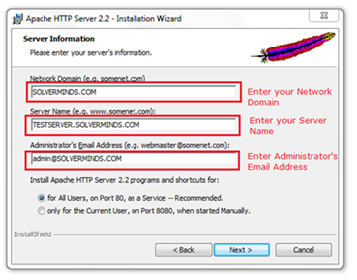
On the next wizard, Select option for all Users, then select any available port to run Apache Server.

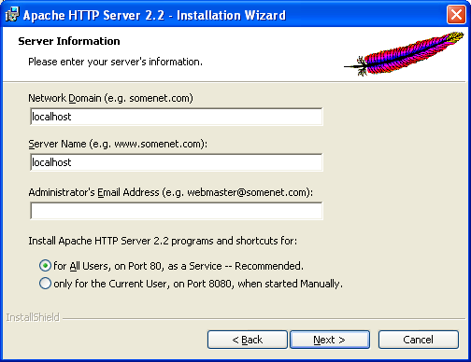

Step 3

Choose the setup type as Typical & Choose your destination folder for installing the files and follow the installation instructions on the screen

Step 4

Change the Listening ports in httpd configuration file available in the path C:\Program Files\Apache Software Foundation\Apache2.2.255\conf.

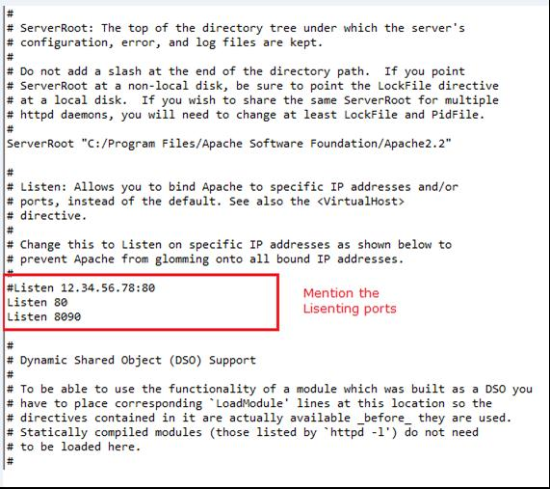

Step 5

Add Include conf/v_host.conf and Include conf/mod-jk.conf at the end of the httpd.conf (configuration file)

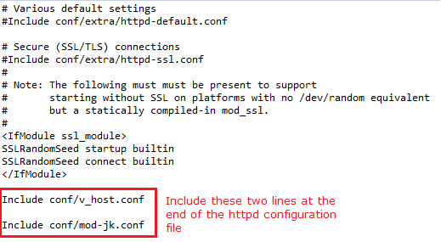

Step 6

Add mod_jk.so file in the following path mentioned below
C:\Program Files\Apache Software Foundation\Apache2.2.255\conf\modules\

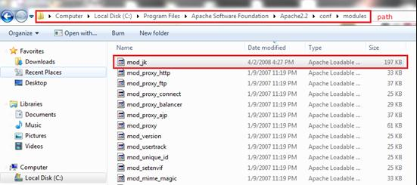

Step 7

Add the Workers Property file in the C:\Program Files\Apache Software Foundation\Apache2.2.255\conf\ folder of Apache 2.2.25

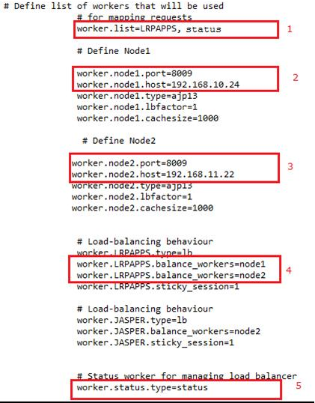

- Add the number of Server Names in the worker.list

- Define the worker.Node 1 port as 8009 by referring AJP 1.3 Connector port which could be found standalone.config.xml. This file is in configuration folder of WILDFLY server ($WildFly-8.2.0.Final\standalone\configuration\standalone-full.xml) .(Application server -WILDFLY)

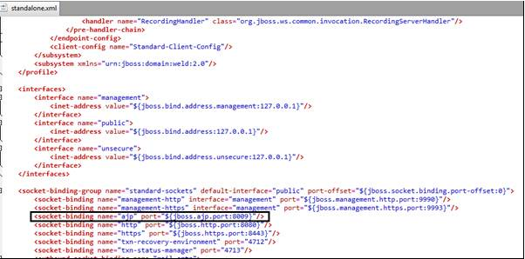

- Define the woker.Node.2 port as same as Node 1 and change the host IP respectively. In future, additional server instance can be added and they can be configured as the same.
- Load balancing behavior were mentioned here, we are having two Nodes hence we mentioned as , it can be extended by increasing the node in incremental order

- entioned as , it can be extended by increasing the node in incremental order

worker.LRPAPPS.balance_workers=node1
worker.LRPAPPS.balance_workers=node2

Define the connection pool size and Connection-pool minimum size in the property file.

worker.vhsnode.port=<AJP PORT>
worker.vhsnode.host=<HOST IP>
worker.vhsnode.type=ajp13
worker.vhsnode.connection_pool_size=250
worker.vhsnode.connection_pool_minsize=100

- Finally Configure,this is for jkstatus type for managing load .
worker.status.type=status

Step 8

Add the mod-jk.conf file in the C:\Program Files\Apache Software Foundation\Apache2.2.255\conf\ folder of the Apache 2.2.25.

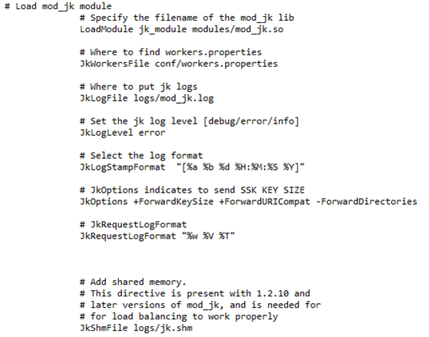

Step 9

Add v_host configuration file in the same C:\Program Files\Apache Software Foundation\Apache2.2.255\conf\ folder of the Apache 2.2.25

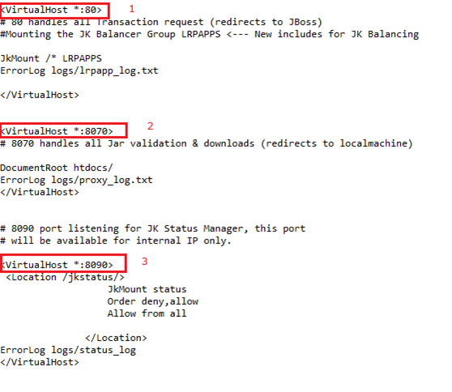

- <VirtualHost *:80> handles all Transaction Request (The port 80 may differ based on the availability of port in the server).
- <VirtualHost *:8090> handles jkmount status

Step 10
Hide the apache version by adding the below configuration in httpd.conf file. This is done for security purposes.
ServerSignature Off
ServerTokens Prod

STEP 11

Locate the in text "logs/Accesslog/access.log" common in httpd.conf file and add the below configuration under the text to rollover log. At the end of each rotation time (after 24 hours) a new log is generated.

CustomLog "|bin/rotatelogs.exe logs/Accesslog/access%Y-%m-%d.log 86400" common

Step 12

Response Time
Look for the text “ LogFormat "%h %l %u %t \"%r\" %>s %b " common” in httpd.conf file and include %T in the same line as below.

LogFormat "%h %l %u %t \"%r\" %>s %b %T" common

Step 13

Context Blocking for security
Add the below context blocking code block in httpd.conf file at the end of the file.
Add the below context blocking code block in v-host file under virtual host tag to restrict the context on port based.
Added the context in location match as “XXX” just for reference. Replace the
“XXX” with original context.

<LocationMatch "^(?!(/XXX))">
Order allow,deny
deny from all
</LocationMatch>

Step 14

Configure the Apache with SSL

1.open the httpd.conf file available in the location "C:\Program Files\Apache Software Foundation\Apache2.2.255\conf\" file.
2.Look for the line LoadModule ssl_module modules/mod_ssl.so and remove any pound sign (#) characters preceding it.
3.Look for the line Include conf/extra/httpd-ssl.conf and remove any pound sign (#) characters preceding it.
4.Modify the "C:\Program Files\Apache Software Foundation\Apache2.2.25\conf\extra\httpd-ssl.conf". These All default options as it is but make sure to modify the following section according to the need:

Parameter | Setting | Default/Custom
VirtualHost _default_ | <443> | Default
ServerAdmin | some@email.com | Custom
DocumentRoot | "Your Root folder location" | Default
ServerName | www.domain.com:443 | Custom
ServerAlias | domain.com:443 | Custom
ErrorLog | "logs/anyFile-error.log" | Custom
CustomLog | "logs/anyFile-access.log" common | Custom
SSLEngine | on | Default
SSLCertificateFile | C:\Program Files)\Apache Software Foundation\Apache2.2.25\conf\server.cert | Custom
SSLCertificateKeyFile | "C:\Program Files\Apache Software Foundation\Apache2.2.25\conf\server.key" | Custom
</VirtualHost>

Make sure that "SSLCertificateFile" and "SSLCertificateKeyFile" are properly located in the above path.

Step 15

Open SSL/HTTPS

NOTE: Ensure that the port 443 is Open in Windows Firewall for public access.

Step 16

Starting Apache Server (httpd.exe -k start )

Enter the following command from command prompt to start the proxy server.

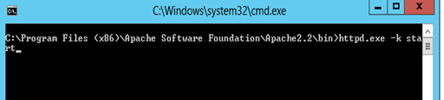

Step 17

Deploy the pulse planet admin console related files which will be available. C:\Program Files\Apache Software Foundation\Apache2.2\htdocs. The below folder holds the admin console related files.

- Kaizen (Folder)
- Tivoli(Folder)

Annexure:
1) mod-jk.conf
2)v_host.conf
3)mod_jk.so
4)workers.properties file

Testing

How do we ensure that the application is working fine?

- Accessing the URL of the application from any browser.
NOTE: Ensure that the browser proxy setting is not enabled.
- Login the application
- Username/Password (check DB user details tables)
- Check the application acceptance criteria as per the test plan

DEPLOYMENT PROCESS DOCUMENT WILL BE PROVIDED SEPARATELY AS PER CLIENT REQUIREMENTS

